**COMSATS University**

**Islamabad**



**Lab Report # 02**

**Real Time Embedded Systems**

**(EEE-446)**

|  |
| --- |
| **Interfacing seven segment display, LCD and Keypad.** |

**Submitted By:**

**Arwa Aamir (FA16-EEE-002)**

**Submitted To:**

**Dr. Ahsen Malik**

**Lab # 02**

**Interfacing seven segment display, LCD and Keypad.**

### Objectives

* Learn working principle to interface seven segment display, numeric keypad and Liquid Crystal Display (LCD) with micro-controller.
* Write code to program above three modules.
* Simulate and hardware demo of above three modules.

**Softwares Used**

* Arduino IDE
* Proteus (Version 8.4)

### Pre Lab

Please read the theoretical background of the interfacing seven segment display, LCD module and keypad.

**Seven Segment Display**

Pin diagram of seven segment display is:

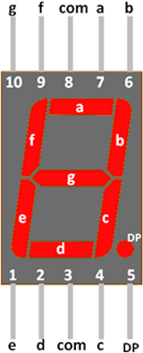

Figure 1: Pin-layout of seven segment using common anode/cathode configuration

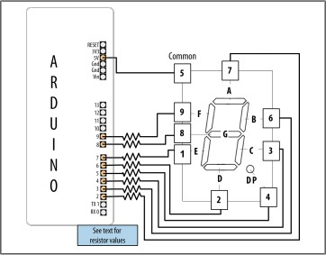

Figure 2: *Connecting a 7-segment display*

Connecting and Using a Text LCD Display

Liquid crystal displays (LCDs) offer a convenient and inexpensive way to provide a user interface for a project. The Arduino software includes the LiquidCrystal library for driving LCD displays

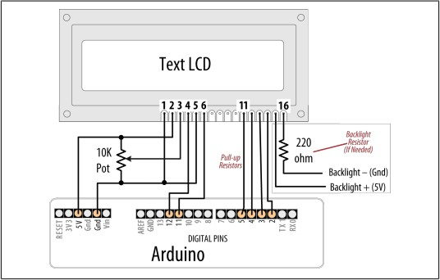

Figure 3: Connections for a text LCD

**IN-LAB TASKS**

# In-Lab Task 1:

**Interface seven segment display and count from 0 to 9 with one second delay.**

|  |  |
| --- | --- |
| **ARDUINO IDE CODE** | **PROTEUS SCHEMATIC** |
| const byte Num[10]={  B11111100,//0  B01100000,//1  B11011010,//2  B11110010,//3  B01100110,//4  B10110110,//5  B00111110,//6  B11100000,//7  B11111110,//8  B11100110,//9  };  const int OUT[8]={2,3,4,5,6,7,8,9};  void setup() {  for (int i=0; i<8 ; i++)  {  pinMode(OUT[i],OUTPUT);  }  }  void loop() {  for (int i=0;i<=9;i++)  {  DISP(i);  delay(500);  }  delay(1000);  }  void DISP(int i)  {  boolean bit_status;  for (int j=0; j<=7; j++)  {  bit_status=bitRead(Num[i],j);  digitalWrite(OUT[j],bit_status);  }  } |  |

# In-Lab Task 2:

**Interface LCD and display you name on first row and you Reg# on second row.**

|  |  |
| --- | --- |
| **ARDUINO IDE CODE** | **PROTEUS SCHEMATIC** |
| #include <LiquidCrystal.h>  const int Rows = 2;  const int Cols = 16;  LiquidCrystal lcd(12,11,5,4,3,2);  void setup()  {  lcd.begin(Cols, Rows);  lcd.print("ARWA AAMIR");  }  void loop()  {  lcd.setCursor(0, 1);  lcd.print("ROLL NO. 002");  } |  |

**POST-LAB TASKS**

# Post Lab Task 1:

**Use three segment displays which should count from 000 till 999 in sixty seconds. You can use decoder ICs for this task.**

|  |  |
| --- | --- |
| **ARDUINO IDE CODE** | **PROTEUS SCHEMATIC** |
| const byte Num[10]={  B00000000,//0  B00000001,//1  B00000010,//2  B00000011,//3  B00000100,//4  B00000101,//5  B00000110,//6  B00000111,//7  B00001000,//8  B00001001,//9  };  const int seg1[4]={2,3,4,5};  const int seg2[4]={6,7,8,9};  const int seg3[4]={10,11,12,13};  void setup() {  for(int i=0;i<=3;i++)  {  pinMode(seg1[i],OUTPUT);  }  for(int i=0;i<=3;i++)  {  pinMode(seg2[i],OUTPUT);  }  for(int i=0;i<=3;i++)  {  pinMode(seg3[i],OUTPUT);  }  }  void loop() {  for (int i=0;i<=9;i++)  {  for (int j=0;j<=9;j++)  {  for (int k=0;k<=9;k++)  {  DISP1(i);  DISP2(j);  DISP3(k);  delay(60.06);  }  }  }  }  void DISP1(int i)  {  boolean bit_status;  for (int j=0; j<=3; j++)  {  bit_status=bitRead(Num[i],j);  digitalWrite(seg1[j],bit_status);  }  }  void DISP2(int i)  {  boolean bit_status;  for (int j=0; j<=3; j++)  {  bit_status=bitRead(Num[i],j);  digitalWrite(seg2[j],bit_status);  }  }  void DISP3(int i)  {  boolean bit_status;  for (int j=0; j<=3; j++)  {  bit_status=bitRead(Num[i],j);  digitalWrite(seg3[j],bit_status);  }  } |  |

**Hardware PCB Design (Ares) :**

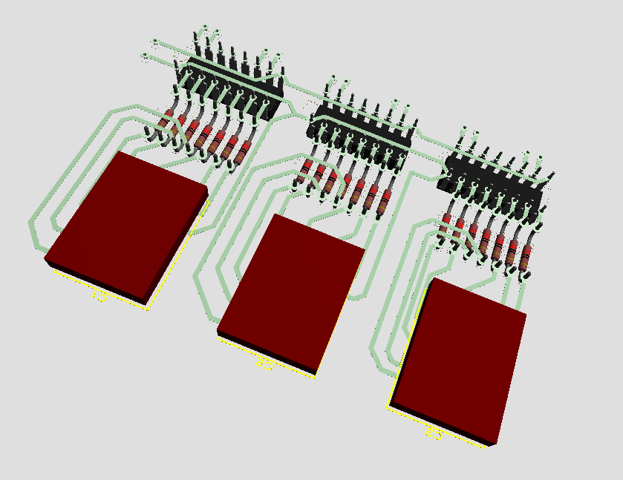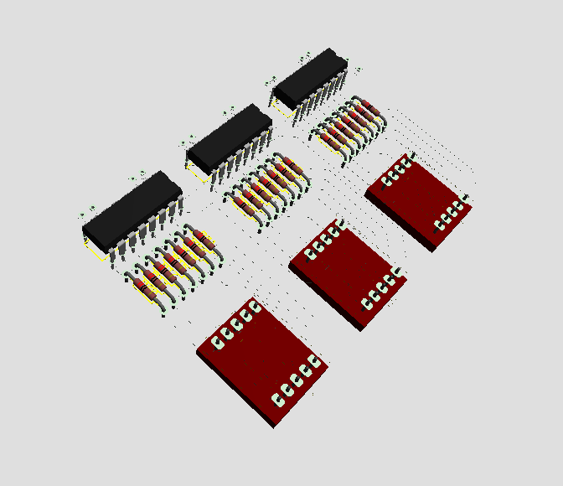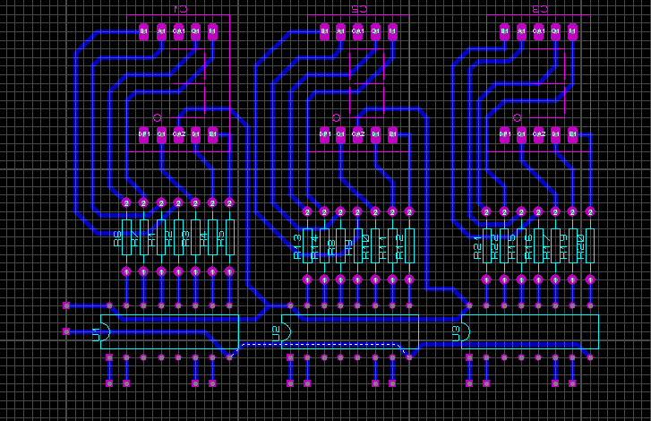

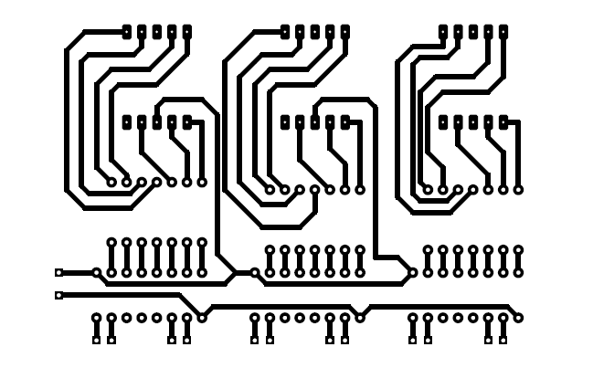

**Critical Analysis/Conclusion:**

|  |
| --- |
| In this lab we interfaced common anode and common cathode7 segment displays with Arduino UNO and also implemented the interfacing on hardware. We also learnt the working principle of LCD and how to interface it with Arduino. Our roll numbers and names were displayed on the LCD using this hardware as well as software.  LCDs and 7 Segment Displays are mainly used to depict data in a form easily understandable to human eye. We can use them for multiple purposes like clocks, counters etc. |

